WPL LAB 7 230905290
Rohan Shenoy CSE D Roll no32

Q1] Develop a web application using Django framework to demonstrate the transfer of
multiple parameters between web pages. User should be presented with a dropdown
list containing car manufacturers, a text box which takes model name of the
manufacturer and a submit button. On submitting the web page, the user is forwarded
to a new page. This new page should display the selected car manufacturer name and
the model name.

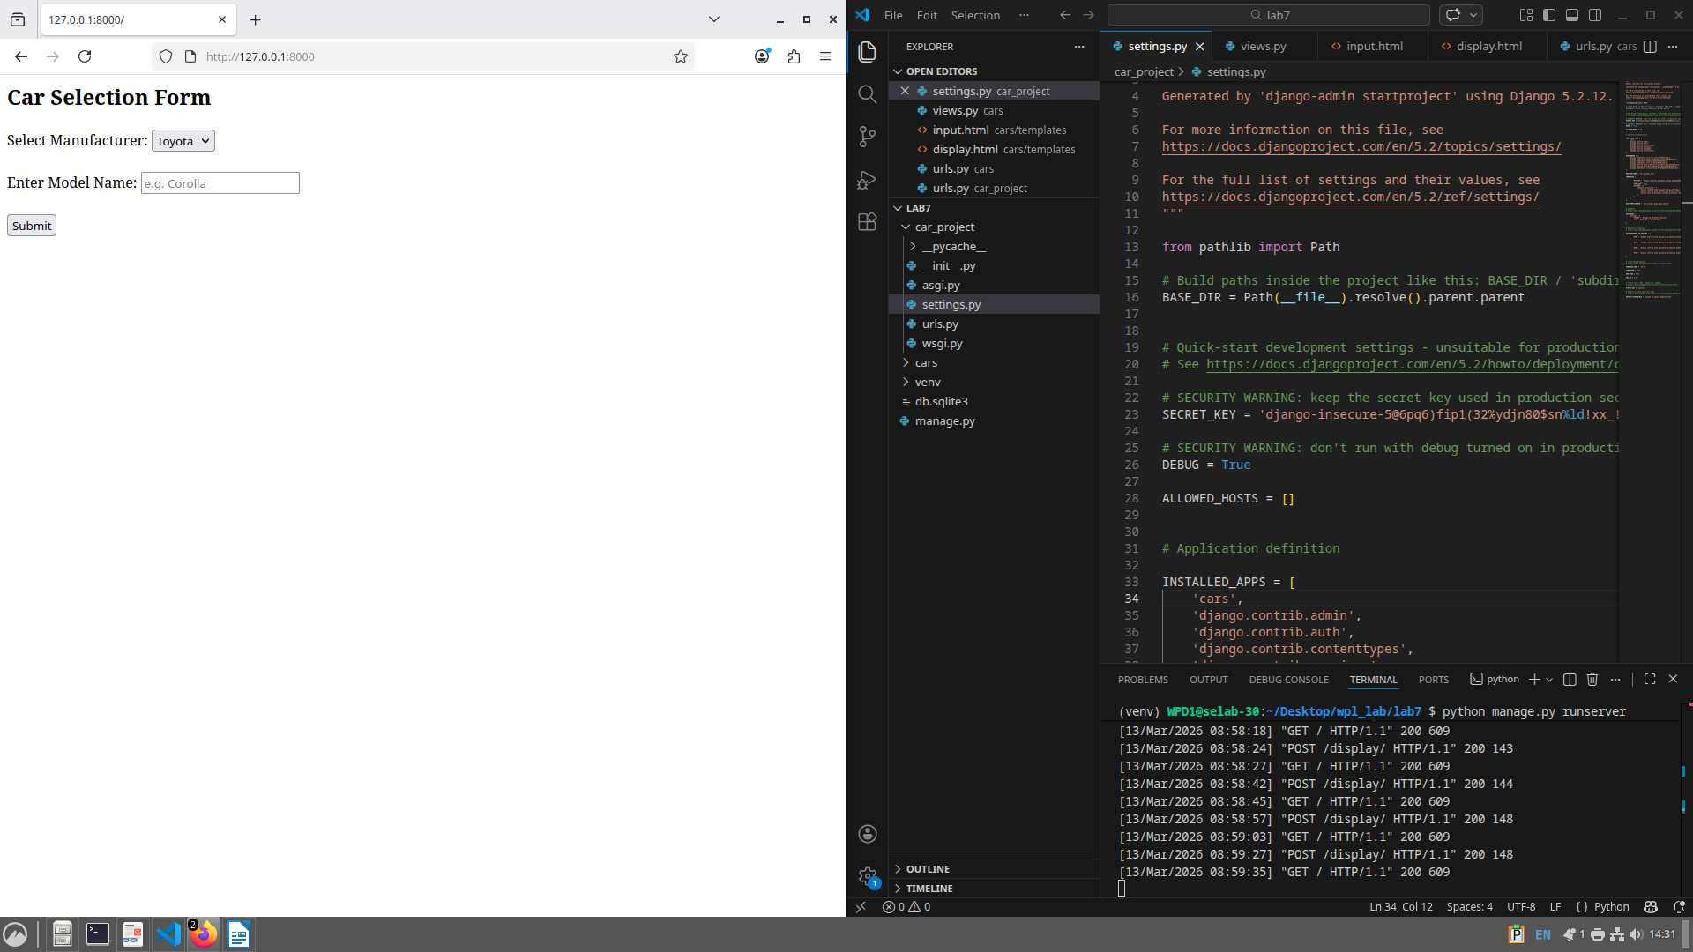

Q2] Create a page firstPage.html with two TextBoxes [Name, Roll], DropDownList
[Subjects], and a button. Create another page secondPage.html with a label and a
button. When the user clicks the button in first Page, he should be sent to the second
page and display the contents passed from first page in the label. The button in second
page should navigate the user back to firstPage. Use Django sessions to transfer
information.

